BRAIN TUMOR CLASSIFICATION

USING

DEEP LEARNING ALGORITHMS

PHASE II REPORT

Submitted by

PRASANNA N

in partial fulfillment for the award of the degree of

MASTER OF ENGINEERING IN
COMPUTER SCIENCE AND ENGINEERING


SARANATHAN COLLEGE OF ENGINEERING
(An Autonomous Institution)
TIRUCHIRAPPALLI 620012

MARCH 2024

DECLARATION

I hereby declare that the work entitled “BRAIN TUMOR CLASSIFICATION USING DEEP LEARNING ALGORITHMS” submitted in partial fulfilment of the requirement for the award of degree in M.E., Anna University, Chennai is a record of my own work and carried out by me during the academic year 2024-2025 under the supervision and guidance of Dr. V Punitha M.E., Ph.D, Professor & Head, Department of Computer Science and Engineering, Saranathan College of Engineering, Trichy. The extent and source of information are derived from the existing literature and have been indicated in the dissertation at appropriate places. The matter embodied in this work is original and has not been submitted for the award of any other degree or diploma, either in this or any other university.

PRASANNA.N

(813823405002)

I certify that the declaration made above by the candidate is true.

DR. V PUNITHA M.E., PH.D,

PROFESSOR &

HEAD OF THE DEPARTMENT OF

COMPUTER SCIENCE AND ENGINEERING

SARANATHAN COLLEGE OF ENGINEERING
(AN AUTONOMOUS INSTITUTION)

BONAFIDE CERTIFICATE

Certified that this project report title “Brain Tumor Classification using Deep Learning Algorithms” the Bonafide work of PRASANNA.N (813823405002) who carried out the supervision Certificate further that to the best of my Knowledge the work reported herein does not form part of any other thesis or dissertation on the basis of which a degree or award was conferred on an earlier occasion on this or any candidate.

SIGNATURE  Dr.V. PUNITHA, M.E, Ph.D.  Professor and Head  Department of CSE  Saranathan College of Engineering  Trichy. | SIGNATURE  Dr.V. PUNITHA, M.E, Ph.D.  Supervisor  Department of CSE  Saranathan College of Engineering  Trichy.

CERTIFICATE OF EVALUATION COLLEGE CODE: 8138
COLLEGE NAME: SARANATHAN COLLEGE OF ENGINEERING

BRANCH & SEMESTER: Computer Science and Engineering & III

NAME OF THE STUDENT | TITLE OF THE PROJECT | NAME OF THE SUPERVISOR WITH DESIGNATION
PRASANNA N (813823405002) | BRAIN TUMOR CLASSIFICATION USING DEEP LEARNING | Dr. V Punitha M.E., Ph.D, Professor & Head of the Department

The project work report for Phase II, submitted by the above mentioned student as part of the partial fulfillment for the Master of Engineering degree in Computer Science and Engineering at Saranathan College of Engineering has been confirmed to be the original work of the student and has been duly evaluated. The report was presented during the viva-voice examination for Phase I, held on .

INTERNAL EXAMINER EXTERNAL EXAMINER

ACKNOWLEGDEMENT

I express my solemn gratitude to Shri. S. RAVINDRAN, Secretary, Saranathan College of Engineering, for his sincere endeavour in educating me in his premier Institution.

I render my sincere thanks to Dr. Y. VENKATARAMANI, Dean (R&D) and Dr. D VALAVAN, Principal, for granting me permission to undertake this project and for their constructive information.

I would like to dedicate my heartfelt thanks to my supervisor Dr. V. PUNITHA, M.E. Ph.D., Head of the Department, Department of Computer Science and Engineering, for being a pillar of support behind the project with munificent guidance and moral encouragement throughout the project.

I owe my deep sense of gratitude to the class coordinator Dr.R. Senthamil Selvi, M.E , Ph.D, Professor Department of CSE, for her valuable help and encouragement during the project.

I thank all my faculty members and non-teaching members of my college who helped me to complete the project successfully and make it a grand success.

PRASANNA N
(813823405002)

ABSTRACT

Brain tumors are among the most life-threatening conditions, requiring early and accurate diagnosis for effective treatment. In this study, we propose a deep learning-based hybrid approach for brain tumor classification using magnetic resonance imaging (MRI). The system integrates three powerful convolutional neural network (CNN) architectures — VGG16, InceptionV3, and ResNet50 — along with a Deep Belief Network (DBN) for feature fusion and final classification.
The process begins with pre-processing MRI scan images to enhance quality and normalize input formats. Each CNN model individually extracts deep features from the input image. These learned features capture various spatial hierarchies:
- VGG16 focuses on fine-grained texture patterns,
- InceptionV3 efficiently captures multi-scale information, and
- ResNet50 learns deep residual representations to reduce vanishing gradients and enhance feature depth.
The extracted features from all three models are concatenated to form a comprehensive feature vector. This vector is then passed to a Deep Belief Network (DBN), which acts as a high-level feature classifier to make the final decision. The DBN refines the prediction and outputs the probability of the image belonging to one of the four tumor categories: Glioma, Meningioma, Pituitary, or No Tumor.
This hybrid ensemble approach improves diagnostic performance by leveraging the complementary strengths of multiple deep learning models. The system is capable of accurately detecting the presence or absence of brain tumors and provides a foundation for developing automated, real-time tumor detection tools to assist radiologists and clinicians.

TABLE OF CONTENTS

CHAPTER NO. | TITLE |  | PAGE NO.
 | ABSTRACT |  | vi
 | LIST OF FIGURES |  | ix
 | LIST OF TABLES |  | x
 | LIST OF ABBREVIATION |  | xi
1 | INTRODUCTION |  | 1
2 | LITERATURE SURVEY
 | 2.1 Multimodal data fusion of adult and pediatric brain tumors with deep learning. |  | 3
 |  | 2.2 A Deep Learning-Based Framework for Automatic Brain Tumors Classification Using Transfer Learning | 4
 |  | 2.3 A Deep Learning Model Based on Concatenation Approach for the Diagnosis of Brain Tumor | 5
 |  | 2.4 Detection of tumors on brain MRI images using the hybrid convolutional neural network architecture  2.5 Drawback | 6  7
3 |  | PROPOSED SYSTEM
 |  | 3.1 Introduction to Deep Learning | 8
 |  | 3.2 Deep Learning in Medical Imaging  3.3 Deep Learning in Glioma  3.3.1 Methodology  3.3.2 Network Architecture | 11  12  14  14

 | 3.4 Extraction | 15
4 | PROPOSED SYSTEM DESIGN
 | 4.1Proposed system design for Brain Tumor Detection | 22
 | 4.2 Flow Diagram | 24
 | 4.3 Validation | 25
5 | SUMMARY AND FUTURE WORK  5.1 Summary  5.2 Future work | 28
 | APPENDICES A | 30
 | APPENDICES B  B.1- The Input Image  B.2 Output | 34  35
 | REFERENCES | 37

LIST OF FIGURES

FIGURE NO | TITLE | PAGE NO
3.1 | Image Classification using Deep Learning and Machine Learning | 8
3.3.1 | Data and predict the overall survival of patient | 13
3.3.2 | Cascaded framework and architecture of CA-CNN | 14
3.3.3 | Architecture of DFKZ Net | 15
5.1  5.3 | Trained Input image of Brain tumor  Confusion Inception V3 Algorithm | 36  36

LIST OF TABLES

TABLE NO. | TITLE | PAGE NO.
4.2.1 | Performance Metrics | 25
4.3.1 | Features Identification | 26

LIST OF ABBREVIATION

ADAM | Adaptive Moment Estimation
AI | Artificial Intelligence
ANN | Artificial Neural Network
BCC | Basal Cell Carcinoma
CAD | Computer-Aided Design
CLS | Classification
CNN | Convolutional Neural Network
DCNN | Deep CNN or Deep Convolutional Neural Network
DL | Deep Learning
DNN | Deep Neural Network
F | False
FCN | Fully Connected Network
FNN | Feed forward Neural Network
FN | False Negative
FP | False Positive
LSTM | Long Short-Term Memory
mel | Melanoma
MSE | Mean Squared Error
NLP | Natural Language Processing

ResNet50 | Residual Network 50
ReLU | Rectified Linear Unit
RMSprop | Root Mean Square Prop
RNN | Recurrent Neural Network
SGD | Stochastic Gradient Descent
SVM | Support Vector Machine
T | True
TN | True Negative
TP | True Positive
VGG | Visual Geometry Group

CHAPTER 1
INTRODUCTION
Brain tumors are a critical health issue that can severely affect a patient's neurological function and quality of life. The early and accurate detection of brain tumors is essential for timely intervention and treatment. Among the various imaging modalities available, Magnetic Resonance Imaging (MRI) is widely used in clinical settings due to its superior ability to visualize soft tissues and identify abnormal growths in the brain.
Traditional diagnostic methods rely heavily on radiologists' expertise, which can be both time-consuming and prone to human error, especially in complex cases. With the rapid advancement of deep learning and computer vision, automated brain tumor detection systems have emerged as promising tools to assist clinicians by increasing diagnostic accuracy and reducing workload.
In this project, we propose a hybrid deep learning approach that combines the strengths of multiple Convolutional Neural Networks (CNNs) namely VGG16, InceptionV3, and ResNet50 with a Deep Belief Network (DBN) to enhance the accuracy and robustness of brain tumor classification. Each CNN model is pre-trained on large-scale image datasets and fine-tuned to extract high-level spatial features from MRI scans. These features are then merged and passed into a DBN, which serves as the final classifier to detect and categorize the presence of brain tumors.
The model is trained to classify MRI images into one of four categories: Glioma, Meningioma, Pituitary, and No Tumor. By leveraging the diverse feature extraction capabilities of different CNN architectures along with the high-level abstraction provided by DBNs, our method aims to improve both the sensitivity and specificity of tumor detection.
This intelligent and automated system is designed to support medical professionals in diagnosing brain tumors more quickly, accurately, and consistently ultimately contributing to better treatment planning and patient outcomes.
Treatment may include some combination of surgery, radiation therapy and chemotherapy.] If seizures occur, anticonvulsant medication may be needed. Dexamethasone and furosemide are medications that may be used to decrease swelling around the tumor. Some tumors grow gradually, requiring only monitoring and possibly needing no further intervention. Treatments that use a person's immune system are being studied. Outcomes for malignant tumors vary considerably depending on the type of tumor and how far it has spread at diagnosis.
Deep learning models, like Convolutional Neural Networks (CNNs), have shown remarkable accuracy in identifying and classifying brain tumors from MRI scans. They can detect subtle patterns and anomalies that might be missed by human eyes, leading to more precise and early diagnoses.
Deep learning can process large volumes of imaging data quickly, which speeds up the diagnostic process. This automation reduces the workload on radiologists and allows them to focus on more complex cases.

CHAPTER 2 LITERATURE SURVEY

Multimodal data fusion of adult and pediatric brain tumors with deep learning(2022)

Author: Sandra Steyaert , Yeping Lina Qiu, Yuanning Zheng, Pritam Mukherjee , Hannes Vogel and Olivier Gevaert

This paper investigates the use of multi-model deep learning to enhance survival predictions for pediatric brain tumor patients by integrating imaging data (Whole slide images) and genomic data (gene expression). It highlights the shortcomings of traditional single-source data approaches in accurately forecasting patient outcomes. The study also emphasizes the need for interpretability in predictive models, proposing pathway analysis as a method to understand the underlying biological mechanism, and suggests the future research should be explore incorporation more diverse data types to improve prediction accuracy.
Data Fusion Techniques: It utilizes early and late fusion strategies to combine imaging and genomic data, with early fusion showing the best performance in experiments.
Grid Search for Learning Rates: A grid search is conducted to optimize learning rates for each data modality, ensuring that the model learns effectively from both histopathology and genomic data.
Joint Training Approach: A complex multimodal framework is implemented where both modalities are learned simultaneously, using different learning rates for histopathology and genomic data to balance their learning speeds.
Deep Learning Model: Specifically, it employs deep neural network(DNNs) to process and analyze the combined data from imaging and genomic sources, enhancing the model’s ability to capture complex patterns in the data.
Transfer Learning: The study lee rages transfer learning apply knowledge gained from a pediatric glioma cohort to predict outcomes in other pediatric brain tumor types, such as ependymoma and medulloblastoma, which have smaller sample sizes.
Cox Proportional Hazards Model: The research integrates traditional survival analysis methods, like the Cox proportional hazards model, with deep learning architectures to improve prognosis prediction on censored data.

A Deep Learning-Based Framework for Automatic Brain Tumors Classification Using Transfer Learning(2022)

Author: Arshia Rehman,Saeeda Naz, Muhammad Imran Razzak,Faiza Akram,Muhammad Imran

The paper explains a brain tumor classification and detection system using deep learning techniques, specifically convolutional neural networks (CNNs). It details the methodology, including the CNNs employed, and the experimental design and results. Additionally, it discusses related work, the effectiveness of transfer learning, and the performance evaluation of the proposed system compared to existing methods.
The brain tumor classification system that utilizes T1-weighted contrast-enhanced MRI images from 233 patients with various brain tumors. The system employs three pretrained CNN architectures AlexNet, GoogleNet, and VGGNet – across three main phase: Preprocessing, feature extraction, and classification. Techeniques such as contrast stretching and data augmentation are used to enhance image quality and increase dataset size, ultimately improving classification accuracy.
Preprocessing and Data Augmentation: Techniques like contrast stretching to enhance MRI image quality and increase dataset size.
Feature Extraction: Utilizing pretrained CNN architecture (AlexNet, GoogLeNet, VGGNet) to extract discriminative features from MRI images.
Classification: Implementation booth fine-tuning and freezing strategies for the CNNs, followed by classification using a linear classifier (SVM) or log-softmax layers.
Deep learning is a subfield of machine learning that focuses on using neural networks with multiple layers (deep architectures) to automatically learn data representations and make prediction. In this paper, deep learning
techniques, specifically convolution neural network (CNNs) are employed for the classification of brain tumors from MRI images. Machine learning, in general, encompasses a broader range of algorithms and techniques for data analysis and prediction, but the paper primarily emphasizes deep learning approaches due to their effectiveness in handling complex image data.

A Deep Learning Model Based on Concatenation Approach for the Diagnosis of Brain Tumor(2023)

Author: Neelum Noreen, Sellappan Palaniappan, Abdul Qayyum, Iftikhar Ahmad, Muhammad Imran And Muhammad Shoaib

This abstract discusses the challenges of classifying brain tumor using MRI, highlighting the distinction between normal and abnormal tumors, as well as the complexities of categorizing different tumor types. It emphasizes the limitation of conventional feature extraction methods and the advantages of deep learning models, particularly CNNs, in automatically extracting relevant features for improved classification. Additionally, it notes the importance of computer-aided diagnosis (CAD) system in assisting neurologists with tumor grading, classification, and detection.
This paper presents a deep learning approach for brain tumor classification using multi-level feature extraction from pre-trained model, specifically DenNet201 and inception v3, it highlights the effectiveness of combining feature from different layers of these models to enhance classification accuracy, achieving high performance metrics. The study emphasize the significance of feature extraction in medical imaging and proposes a method that outperforms traditional single-layer approaches in brain tumor diagnosis.
The methods used for brain tumor classification include machine learning (ML) and deep learning (DL) approaches, specifically convolutional neural networks(CNN) and DenseNet blocks, achieving accuracies of 99.34% and
99.51%, respectively. Additionally, techniquies like feature extraction from multiple layes of pre-trained models and ensemble methods anre employed to enhance classification performance.

Detection of tumors on brain MRI images using the hybrid convolutional neural network architecture(2021)

Author: Ahmet Çinar, Muhammed Yildirim

In this paper, the author discusses the significance of early detection of brain tumors, which are abnormal tissue growths in the brain. It highlights the use of MRI images deep learning methods for classifying these tumors, emphasizing the importance of training networks with large databases to improve diagnostic accuracy rate 86.56% using a convolutional layer and primary capsules for image classification.
This paper focuses on diagnosing brain tumors using MRI images through deep learning techniques, specifically convolutional neural network (CNNs). It introduces a hybrid model based on the RESnet50 architecture, which has been modified to improve classification accuracy, achieving a rate of 97.2%. The study demonstrates the effectiveness of the developed method in classifying brain tumor images compared to traditional methods and other CNN models.
The paper employs deep learning methods, specifically convolutional neural networks (CNNs), for brain tumor classification. It utilizes the Resnet50 model as a base, modifying it by removing the last five layers and adding ten new layers to enhance performance. Additionally, various CNN architectures such as Alexnet, resnet50, Densenet201, Googlenet, and inception v3 are examined for comparison in the study.
Deep learning is a subfield is a of machine learning that utilizes neural networks with multiple layers (deep architectures) to analyze and learn from large datasets, enabling complex pattern recognition and decision-making. In this paper, deep learning methods are specifically applied to classify brain

2.5 MRI-based brain tumor detection using convolutional deep learning methods

and chosen machine learning techniques

Author: Soheila Saeedi, Sorayya Rezayi, Hamidreza Keshavarz and Sharareh R. Niakan Kalhori

Materials and Methods A dataset containing 3264 Magnetic Resonance Imaging (MRI) brain images comprising images of glioma, meningioma, pituitary gland tumors, and healthy brains were used in this study. First, preprocessing and augmentation algorithms were applied to MRI brain images. Next, we developed a new 2D Convolutional Neural Network (CNN) and a convolutional auto-encoder network, both of which were already trained by our assigned hyperparameters. Then 2D CNN includes several convolution layers; all layers in this hierarchical network have a 2*2 kernel function. This network consists of eight convolutional and four pooling layers, and after all convolution layers, batch-normalization layers were applied. The modifed auto-encoder network includes a convolutional auto-encoder network and a convolutional network for classifcation that uses the last output encoder layer of the frst part. Furthermore, six machine-learning techniques that were applied to classify brain tumors were also compared in this study.

Results The training accuracy of the proposed 2D CNN and that of the proposed auto-encoder network were found to be 96.47% and 95.63%, respectively. The average recall values for the 2D CNN and auto-encoder networks were 95% and 94%, respectively. The areas under the ROC curve for both networks were 0.99 or 1. Among applied machine learning methods, Multilayer Perceptron (MLP) (28%) and K-Nearest Neighbors (KNN) (86%) achieved the lowest and highest accuracy rates, respectively. Statistical tests showed a signifcant diference between the means of the two methods developed in this study and several machine learning methods (p-value<0.05).

2.6 A Deep Analysis of Brain Tumor Detection from MR Images Using Deep Learning Networks

Author: Md Ishtyaq Mahmud , Muntasir Mamun and Ahmed Abdelgawad

Creating machines that behave and work in a way similar to humans is the objective

of artificial intelligence (AI). In addition to pattern recognition, planning, and problem-solving, computer activities with artificial intelligence include other activities. A group of algorithms called “deep learning” is used in machine learning. With the aid of magnetic resonance imaging (MRI), deep learning is utilized to create models for the detection and categorization of brain tumors. This allows for the quick and simple identification of brain tumors. Brain disorders are mostly the result of aberrant brain cell proliferation, which can harm the structure of the brain and ultimately result in malignant brain cancer. The early identification of brain tumors and the subsequent appropriate treatment may lower the death rate. In this study, we suggest a convolutional neural network (CNN) architecture for the efficient identification of brain tumors using MR images. This paper also discusses various models such as ResNet-50, VGG16, and Inception V3 and conducts a comparison between the proposed architecture and these models. To analyze the performance of the models, we considered different metrics such as the accuracy, recall, loss, and area under the curve (AUC). As a result of analyzing different models with our proposed model using these metrics, we concluded that the proposed model performed better than the others. Using a dataset of 3264 MR images, we found that the CNN model had an accuracy of 93.3%, an AUC of 98.43%, a recall of 91.19%, and a loss of 0.25. We may infer that the proposed model is reliable for the early detection of a variety of brain tumors after comparing it to the other models.

2.7 DRAWBACKS
The referenced articles exhibit several limitations in their approaches to
Complexity of the Model: may result in challenges related to model interpretability and increased computational demands.
Limited Data Types: it acknowledges that incorporating additional data indicating that the current model may not fully capture all relevant biological information,The paper highlights that existing automated tumor detection systems do not provide satisfactory outputs, indicating a need for more robust computer-aided diagnosis systems. Additionally, manual feature extraction, which can degrade accuracy and efficiency. The challenges in tumor classification due to the heterogeneity and varying properties of tumors also pose significant difficulties. Additionally, these models can be prone to overfitting, especially when trained on small datasets, leading to poor generalization on unseen data. deep learning and machine learning in brain tumor classification include the need for large labeled datasets, which can be difficult and time-consuming to obtain. The main drawback highlighted in the paper is the potential for overfitting, where the model memorizes the training data instead of generalizing well to new, unseen data. This can lead to reduced accuracy in real-world application. Additionally, the reliance on large annotated datasets for training can be a limitation, as acquiring such data can resource-intensive.

CHAPTER 3 PROPOSED SYSTEM
The proposed system aspires to redefine the landscape of automated skin disease classification. By implementing the state-of-the-art deep learning algorithms: VGG-16, Inception v3, and ResNet50, we anticipate a robust and adaptable diagnostic tool capable of accurately identifying acne, bcc, and melanoma. The utilization of diverse algorithms, coupled with meticulous pre- processing, image augmentation, feature extraction, and performance evaluation, positions our system as a pioneering solution with broad applicability in clinical settings. The proposed system aims to develop an intelligent and efficient computer-aided diagnosis (CAD) framework for early and accurate detection of brain tumors using MRI images. This system leverages deep learning methodologies, specifically a hybrid Convolutional Neural Network (CNN) architecture built upon the ResNet50 backbone, to classify brain MRI scans into tumor and non-tumor categories.

INTRODUCTION TO DEEP LEARNING:
Deep learning, a subset of machine learning, emerged as a revolutionary technology, transforming diversity by enabling machines to perform complex tasks previously thought only of human intelligence. This overview covers the fundamental principles, architecture, training systems and applications of deep learning.The basic principle is, the deep learning tries to mimic the learning and decision-making capabilities of the human brain. It is characterized by neural networks, computer models driven by neural connections in the human brain. The essence of neural networks is an artificial network of neurons or perceptron, which process input signals, apply weights, and produce outputs If these neurons are arranged in layers, it’s a neural connection.
Architectures:
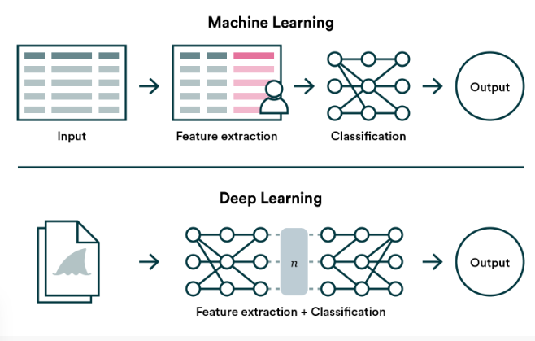
Deep learning has different types of algorithms, each designed for specific tasks. One kind is Feedforward Neural Networks (FNN), which has layers for input, hidden, and output, letting data flow in one direction. Then there's Convolutional Neural Networks (CNN), great for spotting patterns in images through special layers. Recurrent Neural Networks (RNNs) are good with sequences, adding memory for tasks like understanding language. And there's Long Short-Term Memory (LSTM) networks that fix a problem in RNNs called the missing gradient issue.
Fig.3.1 The Process of Image Classification using Deep Learning and Machine Learning
- Input Module:
  - MRI brain images (grayscale or RGB) are provided as input.
  - Images are resized to the appropriate dimensions (e.g., 224x224) depending on the backbone model used.
- Pretrained CNN Backbone:
  - Utilizes ResNet50, a highly accurate and deep residual learning framework.
  - The last 5 layers of the standard ResNet50 model are removed to tailor the model to the brain tumor classification task.
- Custom Layer Stack:
  - Added layers include:
    - ReLU Activation
    - Batch Normalization
    - Dropout Layer (to prevent overfitting)
    - Two Fully Connected Layers
    - MaxPooling Layer
    - Softmax Activation
    - Final Classification Layer
  - This customization increases the depth of the network while preserving the core CNN structure.
- Training and Optimization:
  - Optimizer: Stochastic Gradient Descent with Momentum (SGDM)
  - Learning Rate: 1.0
  - Epochs: 5
  - Mini-batch Size: 16
- Dataset:
  - Brain MRI dataset obtained from Kaggle, consisting of:
    - 98 images without tumors
    - 155 images with tumors
- Output Module:
  - The model outputs a class prediction: either "Tumor" or "No Tumor".
  - Evaluation metrics such as Accuracy, Sensitivity, Specificity, and Confusion Matrix are used to assess performance.

System Advantages
- Achieves 97.2% classification accuracy using the hybrid model.
- Outperforms standard models like AlexNet, DenseNet201, InceptionV3, and GoogLeNet.
- Demonstrates high reliability and potential for integration into real-world medical imaging tools.
- Reduces reliance on manual feature extraction and domain-specific preprocessing.
Training Processes:
Training a deep learning model involves optimizing its parameters to minimize the difference between predicted and actual outcomes. The process typically uses labeled data, where the model recognizes patterns and components. The back propagation algorithm further adjusts the weight of the neural network based on the gradient of the loss function, and optimizes the model for better performance. Training can take various optimizations Techniques, such as stochastic gradient descent (SGD), ADAM, or RMS prop, to speed convergence and improve the performance and efficiency.
Activation Functions:
weighted input from the node into an output value to send to the next hidden layer or as output. ReLU is popular for its simplicity and effectiveness in mitigating the vanishing gradient problem, allowing for faster training.

Loss Functions:
Loss function is a method of evaluating how well the algorithm models the dataset they measure the gap between predicted and actual results during training. Mean Squared Error (MSE) is handy for regression, while Cross- Entropy Loss works well for classification [9].
Regularization Techniques:
Overfitting is an undesirable deep learning behavior that occurs when the model gives accurate predictions for training data but not for new data. Regularization Techniques like dropout, L1, and L2 regularization tackle over fitting, where a model is great on training data but falters with new data. Dropout randomly turns off some neurons during training, adding redundancy and improving overall performance.
Transfer Learning:
Transfer learning leverages pre-trained models on large datasets for new, related tasks. This approach saves computation time and resources, as the model has already learned useful features. Fine-tuning allows adapting the Pre-trained model to the specific requirements of the new task, making transfer learning a powerful tool for various applications.
Applications:
Deep learning is doing incredible things in many areas. Here are some of its applications:

Vision and Imagery:
  - Facial recognition: Think unlocking phones with your face or beefing up security systems.
  - Image segmentation: It's the brain behind recognizing objects in pics, steering self-driving cars, and even helping out in medical imaging.
  - Video analysis: From picking out sports highlights to managing traffic and guiding autonomous robots.

Language and Communication:
  - Natural language processing (NLP): Ever chatted with a chat bot or had a virtual assistant help you out? That's deep learning in action.
  - Speech recognition: Whether you're doing a voice search or getting text from spoken words, deep learning is there.
  - Text generation: It's the genius behind personalized marketing, creative writing, and even journalism.

Health and Medicine:
  - Medical image analysis: Deep learning helps spot things like cancer and speeds up finding new drugs tailored to you.
  - Robotic surgery: Imagine robots with pinpoint accuracy doing delicate surgeries that are easier on you.

Robots and Artifacts:
- Self-driving cars: They can think, navigate, and make decisions all on their own, thanks to deep learning.
- Industrial robots: These robots are like the superheroes of the factory, super skilled and handling all kinds of tricky tasks.
- Drones and delivery robots: Deep learning guides them to navigate and avoid obstacles on their own.

Other Uses:
- Fraud detection: It's the superhero spotting sketchy stuff in financial transactions.

- Suggested Suggestions: You know those personalized recommendations for things you might like? Yup, deep learning again.
- Scientific analytics: It's like a super-fast brain helping scientists analyze data and make discoveries in all sorts of fields.

DEEP LEARNING IN MEDICAL IMAGING
The integration of deep learning, a branch of artificial intelligence, made medical imaging evolve at a transformative rate. This complex interplay between technology and healthcare is revolutionizing diagnostic testing and providing unprecedented insights into medical conditions through highly accurate and efficient imaging analysis. Neural networks, which are inspired by the human brain, consist of interconnected nodes for processing information. In medical imaging, these networks are trained to detect complexity in images, making it easier to automatically diagnose diseases.

DEEP LEARNING IN GLIOMA:

The segmentation of gliomas in pre-operative MRI scans, conventionally done by expert board-certified neuroradiologists, can provide quantitative morphological characterization and measurement of gliomas sub-regions. It is also pre-requisite for survival prediction since most potent features are derived from the tumor region. This quantitative analysis has great potential for diagnosis and research, as it can be used for grade assessment of glioma and planning of treatment statergies. But this task is challenging due to the high variance in appearance and shape, ambiguous boundaries and imaging artifacts. Until now, automatic segmentation of brain tumor in multimodal MRI scans is still one of the most difficult tasks in medical image analysis. In recent years, deep convolutional neural networks (CNNs) have achieved great success in the field of computer vision. Inspired by the biological structure of visual cortex, CNNs are artificial neural networks with multiple hidden convolutional layers between the input and output layers. They have non-linear property and are capable of extracting higher level representative features. CNNs have been applied into a wide range of fields and achieved state-of the-art performance on task such as image recognition, instance detection, and semantic segmentation.

Methodology:

The fig 3.3.1 explains the methodology in neural network architecture for robust performance through voting/majority rule. Then radiomics features are extracted from tumor sub-regions and total tumor volume. Next, decision tree repressor with gradient boosting is used to fit the training data and rank the importance of each feature based on variance reduction, and cross validation is used to choose the optimal number of top ranking feature to use.

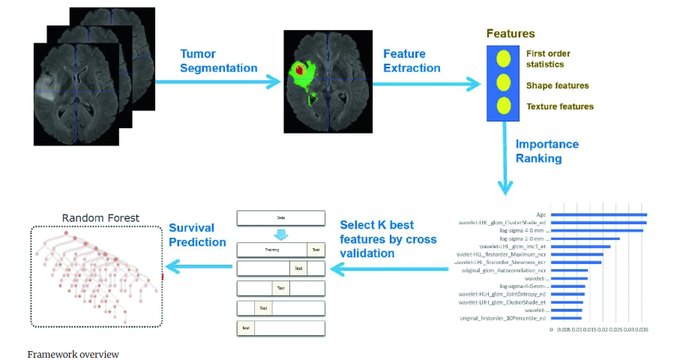
Fig 3.3.1 Data and predict the overall survival of patient

    - Network Architecture:
The fig 3.3.2 explains the variety of models have been proposed for tumor segmentation. Generally, they differ in model depth, filter number, connection way and others. Different model architectures can lead to different model performance and behavior. By training different kinds of model separately and merge the result, the model variance can be decreased and the overall performance can be improved.

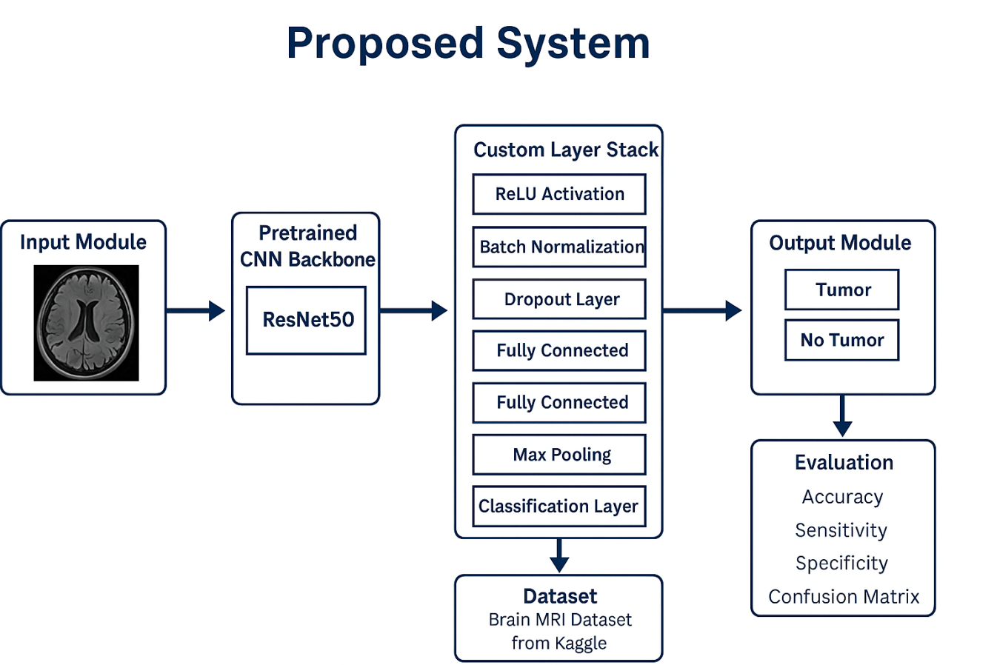

Fig 3.3.2 Proposed System

    - DFKZ Net:
The fig 3.3.3 explains the architecture second network we employ is DFKZ Net, which was proposed by Isensee et al. from German Cancer Research Center (DFKZ). This network is inspired by U-Net. It employs a context encoding pathway that extracts increasingly abstract representations of the input, and a decoding pathway used to recombine these representations with shallower features to precisely segment the structure of interest. The context encoding pathway consists of three content modules, each has two 3×3×3 convolutional layers and a dropout layer with residual connection. The decoding pathway consists of three localization modules, each contains a 3×3×3 convolutional layer followed by a 1×1×1 convolutional layer. For the decoding pathway, the output of layers of different depth is integrated by elementwise summation, thus the supervision can be injected deep in the network.
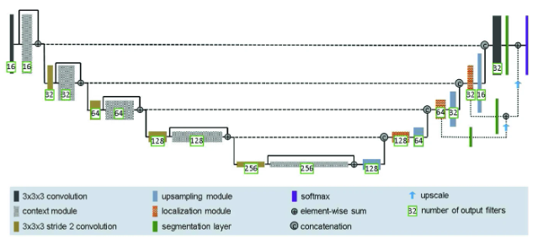
Fig 3.3.3 Architecture of DFKZ Net

$$L=-\frac{2}{|K|}=\sum_{k∈K}{\frac{\sum_{i}{u_{i(k)}v_{i(k)}}}{\sum_{i}{u_{i(k)}}+\sum_{i}{v_{i(k)}}}}$$

3D U-Net:
U-Net [5, 14] is a classical network for biomedical image segmentation. It consists of a contracting path to capture context and a symmetric expanding path that enables precise localization with extension. Each pathway has three convolutional layers with dropout and pooling. And the contracting pathway and expanding pathway are linked by skip-connections. Each layer contains 3×3×3 convolutional kernels. The first convolutional layer has 32 filters, while deeper layers contains twice filters than previous shallower layer.

3.4 DEEP LEARNING ALGORITHMS
Deep learning has revolutionized computer vision, enabling machines to interpret and understand visual information. In this proposed system, we will delve into three prominent algorithms in deep learning: Deep Belief Network, VGG-16 (Visual Geometry Group 16-layer network), and ResNet50 (Residual Network with 50 layers), Inception V3

DEEP BELIEF NETWORK ALGORITHM

A Deep Belief Network (DBN) is a type of generative graphical model, or a class of deep neural network, composed of multiple layers of latent variables (hidden units).

Key Features:
Architecture: DBNs are made up of multiple layers of stochastic latent variables. These variables are binary and are often referred to as feature detectors or hidden units2.
Training: DBNs are trained in a greedy layer-wise fashion. This means that each layer is trained individually before moving on to the next one2. The first layer is typically trained as a Restricted Boltzmann Machine (RBM), and subsequent layers are trained using the output of the previous layer as input.
Generative Model: DBNs can be used to generate new data that is similar to the training data. This makes them useful for tasks like image reconstruction and anomaly detection.
Applications: DBNs have been applied in various fields, including image recognition, speech recognition, and natural language processing.
A deep belief net can be viewed as a composition of simple learning modules each of which is a restricted type of Boltzmann machine that contains a layer of visible units that represent the data and a layer of hidden units that learn to represent features that capture higher-order correlations in the data. The two layers are connected by a matrix of symmetrically weighted connections, W , and there are no connections within a layer. Given a vector of activities v for the visible units, the hidden units are all conditionally independent so it is easy to sample a vector, h , from the factorial posterior distribution over hidden vectors, p(h|v,W) . It is also easy to sample from p(v|h,W) . By starting with an observed data vector on the visible units and alternating several times between sampling from p(h|v,W) and p(v|h,W) , it is easy to get a learning signal. This signal is simply the difference between the pairwise correlations of the visible and hidden units at the beginning and end of the sampling.The key idea behind deep belief nets is that the weights, W , learned by a restricted Boltzmann machine define both p(v|h,W) and the prior distribution over hidden vectors, p(h|W) , so the probability of generating a visible vector, v
can be written as:

$$p\left(v\right)=\sum_{h}{p\left(h | W\right)p(v|h,W)}$$

After learning W , we keep p(v|h,W) but we replace p(h|W) by a better model of the aggregated posterior distribution over hidden vectors – i.e. the non-factorial distribution produced by averaging the factorial posterior distributions produced by the individual data vectors.

as the training data for the next learning module. Hinton, Osindero and Teh (2006) show that this replacement, if performed in the right way, improves a variational lower bound on the probability of the training data under the composite model.
INCEPTION V3:
Inception v3 is an advanced convolutional neural network (CNN) architecture developed by Google as part of the Inception family. It builds on the strengths of its predecessors, incorporating several improvements to enhance performance and efficiency. Here’s a detailed look at its components and features:
Key Features of Inception v3
- Inception Modules: These modules use multiple filter sizes to process the input and capture different types of features. This allows the network to learn complex patterns efficiently without increasing computational cost significantly.
- Factorized Convolutions: Inception v3 uses factorized convolutions to reduce the computational expense. Instead of using a single large convolutional filter, it splits it into smaller, more manageable ones (e.g., a 5x5 filter becomes two 3x3 filters).
- Auxiliary Classifiers: These are added during training to combat the vanishing gradient problem. They act as regularizers and provide additional gradient signals, helping the main network layers learn more effectively.
- Grid Size Reduction: Inception v3 includes techniques to efficiently downsample the grid size while maintaining feature extraction. This improves computational efficiency and maintains the quality of feature maps.
- Batch Normalization: Batch normalization layers are used extensively to stabilize and accelerate the training process. By normalizing the inputs for each mini-batch, it helps the network converge faster and achieve higher accuracy.
Inception v3 has shown to be effective for various image recognition tasks and has been widely used in both academic research and practical applications. It balances complexity and efficiency, making it a robust choice for large-scale image classification.

Applications of Inception v3

Inception v3 is widely used in various domains, especially in tasks requiring accurate image recognition. Some common applications include:
- Image Classification: Recognizing and categorizing objects within images.
- Object Detection: Identifying and locating objects within images.
- Medical Imaging: Assisting in the analysis of medical images for disease detection and diagnosis.
- Face Recognition: Identifying and verifying individuals based on their facial features.
VGG-16(Visual Geometry Group):
VGG16 is a convolutional neural network model proposed by K. Simonyan and A. Zisserman from the University of Oxford in the paper “Very Deep Convolutional Networks for Large-Scale Image Recognition”. The model achieves 92.7% top-5 test accuracy in ImageNet, which is a dataset of over 14 million images belonging to 1000 classes.

Key Features of VGG-16
- Architecture:
  - VGG-16 has 16 layers with learnable parameters, including 13 convolutional layers and 3 fully connected layers. This structure is relatively deep, which allows the network to learn complex features from the input images.
- Convolutional Layers:
  - The convolutional layers use 3x3 filters with a stride of 1 and padding to preserve the spatial resolution of the input image. This helps in capturing fine details and spatial hierarchies.
- Pooling Layers:
  - Max pooling layers follow some of the convolutional layers, using 2x2 filters with a stride of 2. This reduces the spatial dimensions of the feature maps, allowing for a more efficient computation.
- Fully Connected Layers:
  - After the convolutional and pooling layers, the architecture includes three fully connected layers. The first two fully connected layers have 4096 nodes each, and the final layer has 1000 nodes, which correspond to the classes in the ImageNet dataset.
- Activation Functions:
  - Rectified Linear Unit (ReLU) activation functions are used after each convolutional and fully connected layer, which helps in introducing non-linearity and accelerates the convergence of the network.
- Softmax Output:
  - The output layer uses a softmax activation function to classify the input image into one of 1000 possible categories.

Strengths of VGG-1

Simplicity and Uniformity: The use of 3x3 convolutional filters throughout the network makes the architecture simple and consistent.

Deep Structure: The depth of the network allows it to learn complex and abstract features, improving its performance on image recognition tasks.

Transfer Learning: VGG-16 is commonly used for transfer learning in various applications.

Applications of VGG-16

VGG-16 has been widely used in various computer vision tasks, including

Image Classification: Recognizing and categorizing objects within images.

Object Detection: Identifying and locating objects within images.

Semantic Segmentation: Segmenting different parts of an image based on their semantic meaning.

Style Transfer: Applying the style of one image to the content of another, creating artistic effects.

Its robust performance and simplicity have made VGG-16 a popular choice for both academic research and practical applications in the field of computer vision.

ResNet-50(Residual Network-50):

ResNet-50 or Residual Network-50, is a popular deep convolutional neural network architecture that was developed by Microsoft Research. It's well-known for its efficiency and ability to train deep networks effectively. Here’s a breakdown of what makes ResNet-50 special.

Key Features of ResNet-50

Residual Blocks:

The core idea of ResNet is the introduction of residual blocks. These blocks use "skip connections" or "shortcuts" that bypass one or more layers. This helps in solving the vanishing gradient problem, allowing for training of much deeper networks.
- Architecture:
ResNet-50 has a total of 50 layers that include convolutional layers, pooling layers, batch normalization layers, and fully connected layers. The main components are:
    - Convolutional Layers: These layers extract features from the input images.
    - Batch Normalization: Applied after each convolution to stabilize the learning process.
    - Activation Functions: ReLU (Rectified Linear Unit) is commonly used to introduce non-linearity.
    - Pooling Layers: Used to reduce the spatial dimensions of the feature maps.
    - Fully Connected Layers: Used towards the end for classification.
    - Skip Connections: Bypass one or more layers, helping with gradient flow during training.
- Block Structure:
    - ResNet-50 is composed of multiple residual blocks, each containing a series of convolutional, batch normalization, and ReLU layers. The skip connections add the input of the block to the output, ensuring information is passed through the network effectively.
- Efficiency:
    - By using residual blocks, ResNet-50 mitigates the degradation problem faced by very deep networks. It allows for training deeper networks without the issue of vanishing or exploding gradients.

CHAPTER 4

PROPOSED SYSTEM DESIGN
This system involves outlining the components, functionalities, and architecture of a system that is planned for implementation. Let's sketch a high-level design for a deep learning-based brain tumor detection system using models like Inception v3, VGG-16, ResNet-50, and Deep Belief Networks (DBNs).

4.1 Proposed System Design for Brain Tumor Detection

1. Data Preprocessing:

Image Resizing: Resize all images to the required input size for each model (e.g., 299x299 for Inception v3, 224x224 for VGG-16 and ResNet-50)

Normalization: Normalize pixel values to a standard range (e.g., 0-1 or -1 to 1)

Data Augmentation: Apply transformations like rotation, flipping, and scaling to increase dataset size and diversity.

Data Collection: Source MRI images of brain tumors and healthy brains from medical databases and hospitals.

Classification and Architecture

Inception v3:

Utilize inception modules with different filter sizes to capture diverse features.

Include auxiliary classifiers to improve gradient flow.

VGG-16:

Employ a deep architecture with multiple convolutional and fully connected layers.

Use small 3x3 filters consistently throughout the network.

Deep Belief Network (DBN):
Construct a network of stacked Restricted Boltzmann Machines (RBMs) for unsupervised pre-training followed by supervised fine-tuning.
  - Training Process:
- Split Dataset: Divide the dataset into training, validation, and test sets.
- Train Models: Train each model using the training set, validate with the validation set, and fine-tune hyper parameters.
- Layer-wise Training for DBNs: Train each RBM layer by layer before fine-tuning the entire network.
  - Evaluation and Validation:
- Model Evaluation: Use performance metrics like accuracy, precision, recall, and F1-score to evaluate each model on the test set.
- Cross-Validation: Perform cross-validation to ensure robustness and generalizability of the models.
  - Prediction and Deployment:
- Model Integration: Integrate the trained models into a single system that can accept new MRI images and provide predictions.
- User Interface: Develop a user-friendly interface for medical professionals to upload images and view results.

4.2 Flow Diagram:
Brain tumor images
Data Processing

Data Collection

Classification

Inception V3
ResNet-50
VGG-16

Deep Belief Network

Precision
Accuracy
F1-Score
Recall

Identify the tumor

Types of tumors,
Glioma, Meningioma, Pituitary
No tumor & End session

End Session

  - Post-Processing and Reporting:
- Analyze Predictions: Apply post-processing techniques to refine tumor detection and segmentation results.
- Generate Reports: Create detailed reports and visualizations of the detected brain tumors, including their size, location, and characteristics.
4.2.1 PERFORMANCE METRICS
ALGORITHM | ACCURACY | PRECISION | RECALL | F1-SCORE
VGG-16 | 80-88% | 96% | 91% | 91.78%
INCEPTION V3 | 94.34% | 98% | 98% | 98.52%
ResNet-50 | 94% | 96% | 92.6% | 91.29
Deep Belief Network | 99% | 97% | 998% | 100%

4.3 Validation
Validation is the process of evaluating the model on a separate validation dataset during training to tune hyperparameters and ensure the model's performance is generalizable.
Steps in Validation:
- Dataset Split:
  - Split the collected data into training, validation, and test sets (commonly 70% training, 20% validation, and 10% test).

- Training with Validation:
  - Train the model on the training set while periodically evaluating it on the validation set.
  - Monitor performance metrics like accuracy, loss, precision, recall, and F1-score.
  - Use early stopping if the validation performance stops improving to prevent overfitting.
- Hyperparameter Tuning:
  - Adjust hyperparameters (e.g., learning rate, batch size, number of layers) based on the validation performance.
  - Techniques like grid search or random search can be used for systematic tuning.
- Cross-Validation:
  - Optionally, perform k-fold cross-validation, where the training set is divided into k subsets. The model is trained k times, each time using a different subset as the validation set and the remaining as the training set.
  - Average the results to get a more robust estimate of the model's performance.
4.3.1 FEATURES IDENTIFICATION

FEATURES | VGG 16 | Inception V3 | ResNet50
Grid-based  Detection | YES | NO | NO
Bounding Box  Prediction | YES | NO | NO
Real-time  Detection | YES | NO | NO

VGG16:

VGG16 is a convolutional neural network (CNN) model known for its simplicity and effectiveness in image recognition. In brain tumor detection, VGG16 is often used to classify MRI images into categories such as "tumor" and "no tumor"1.

Inception V3:

Inception V3 is another powerful CNN model that excels at feature extraction from images. It uses multiple filter sizes in parallel to capture features at different scales, making it effective for detecting various tumor types in MRI images3. In brain tumor detection, Inception V3 can classify images into categories like glioma, meningioma, and pituitary tumors.

ResNet-50:

ResNet-50 is a deep residual network that uses skip connections to enable training of very deep networks. It is highly effective in feature extraction and classification tasks4. In brain tumor detection, ResNet-50 can identify and classify different tumor types with high accuracy by learning complex features from MRI images.

CHAPTER 5
SUMMARY AND FUTURE WORK

5.1 Summary
In our journey through deep learning and its application to brain tumor detection, we've explored several advanced architectures, including Inception v3, VGG-16, ResNet-50, and Deep Belief Networks (DBNs). Each of these models has unique features that make them suitable for complex tasks like medical imaging.
- Inception v3: Known for its Inception modules and factorized convolutions, it captures various levels of features efficiently.
- VGG-16: Simple yet powerful, with a consistent use of 3x3 convolutions, it excels in deep feature extraction.
- ResNet-50: Utilizes residual blocks to overcome vanishing gradients, allowing for deeper networks.
- Deep Belief Networks (DBNs): Generative models that learn features layer by layer using Restricted Boltzmann Machines (RBMs).The proposed system design for brain tumor detection includes steps such as data collection, preprocessing, model training, evaluation, and deployment. Each step ensures the system is accurate, efficient, and robust.

5.2 My accomplishments

Backend:
- FastAPI: A high-performance web framework used to build the backend REST APIs for model inference and user communication.
- Python: The core programming language used for data handling, model integration, and backend logic.

Frontend:
- HTML/CSS/JavaScript (optional addition if applicable): Used to develop a clean and responsive user interface for uploading scans and displaying results.

Models Used
To improve classification accuracy, we used an ensemble of traditional and deep learning models:

a. Deep Belief Network (DBN)
- A generative, unsupervised neural network model used for initial feature extraction and classification.
- Suitable for handling nonlinear data patterns.

b. VGG16
- A 16-layer deep convolutional neural network known for its simplicity and high performance on image classification tasks.
- Used for extracting hierarchical features from MRI scans.

c. InceptionV3
- A deep CNN model that utilizes multiple filter sizes at each layer to capture different image features.
- Known for being efficient and accurate for image recognition tasks.

d. ResNet50
- A 50-layer deep residual network that prevents vanishing gradient issues using skip connections.
- Used for deep feature extraction and robust tumor classification.

Functionality
- Users can upload MRI brain scan images through the web interface.
- The uploaded image is processed and passed through the ensemble of trained models.
- The system returns the predicted tumor class:
Glioma, Meningioma, Pituitary, or No Tumor.
- Results are displayed in real time through the frontend.

- Explainability and Interpretability: Developing methods to explain and interpret model predictions can build trust among medical professionals and ensure the model's decisions are understandable.
- Real-Time Deployment: Enhancing the system to support real-time predictions and analysis can significantly benefit clinical workflows, providing timely insights and aiding in decision-making.
- Continuous Learning: Implementing systems that can continuously learn from new data can keep the models up-to-date with the latest medical advancements and patient data.
- Collaborative Research: Encouraging collaboration between AI researchers and medical professionals can lead to more innovative solutions and ensure the models are aligned with clinical needs.

APPENDICES A

Recognition of datasets for brain tumor classification using python code:
Code for deep learning algorithm DEEP BELIEF NETWORK:
import tensorflow as tf
from tensorflow.keras.applications import VGG16, InceptionV3, ResNet50
from tensorflow.keras.models import Model
from tensorflow.keras.layers import GlobalAveragePooling2D
from sklearn.neural_network import BernoulliRBM
from sklearn.pipeline import Pipeline
from sklearn.linear_model import LogisticRegression
from sklearn.preprocessing import StandardScaler
import numpy as np
import joblib

# Define dataset paths
train_dir = "D:/me/phase-2 project/archive (2)/Training" # Update with actual dataset path
test_dir = "D:/me/phase-2 project/archive (2)/Testing" # Update with actual dataset path

# Load dataset function
def load_dataset(data_dir, img_size=(224, 224)):
dataset = tf.keras.preprocessing.image_dataset_from_directory(
data_dir,
image_size=img_size,
batch_size=32,
label_mode='int'
)
images, labels = [], []
for img_batch, label_batch in dataset:
images.append(img_batch.numpy())
labels.append(label_batch.numpy())
return np.concatenate(images, axis=0), np.concatenate(labels, axis=0)

# Load training and testing data
X_train, y_train = load_dataset(train_dir)
X_test, y_test = load_dataset(test_dir)

# Function to extract features
def extract_features(model, X):
return model.predict(X, verbose=1)

# Load pre-trained models without top layers
vgg16 = VGG16(weights='imagenet', include_top=False, input_shape=(224, 224, 3))
inception_v3 = InceptionV3(weights='imagenet', include_top=False, input_shape=(224, 224, 3))
resnet50 = ResNet50(weights='imagenet', include_top=False, input_shape=(224, 224, 3))

# Add global average pooling layers
vgg16_model = Model(inputs=vgg16.input, outputs=GlobalAveragePooling2D()(vgg16.output))
inception_v3_model = Model(inputs=inception_v3.input, outputs=GlobalAveragePooling2D()(inception_v3.output))
resnet50_model = Model(inputs=resnet50.input, outputs=GlobalAveragePooling2D()(resnet50.output))

# Freeze layers
for model in [vgg16_model, inception_v3_model, resnet50_model]:
for layer in model.layers:
layer.trainable = False

# Extract features from models
X_train_vgg16 = extract_features(vgg16_model, X_train)
X_train_inception = extract_features(inception_v3_model, X_train)
X_train_resnet = extract_features(resnet50_model, X_train)

X_test_vgg16 = extract_features(vgg16_model, X_test)
X_test_inception = extract_features(inception_v3_model, X_test)
X_test_resnet = extract_features(resnet50_model, X_test)

# Concatenate extracted features
X_train_features = np.concatenate([X_train_vgg16, X_train_inception, X_train_resnet], axis=1)
X_test_features = np.concatenate([X_test_vgg16, X_test_inception, X_test_resnet], axis=1)

# Normalize features
scaler = StandardScaler()
X_train_features = scaler.fit_transform(X_train_features)
X_test_features = scaler.transform(X_test_features)

# Define Deep Belief Network (DBN)
rbm1 = BernoulliRBM(n_components=512, learning_rate=0.01, n_iter=10, random_state=42)
rbm2 = BernoulliRBM(n_components=256, learning_rate=0.01, n_iter=10, random_state=42)
classifier = LogisticRegression(max_iter=1000, random_state=42)

# Combine into a single pipeline
dbn_pipeline = Pipeline(steps=[
('scaler', StandardScaler()),
('rbm1', rbm1),
('rbm2', rbm2),
('classifier', classifier)
])

# Train the model
dbn_pipeline.fit(X_train_features, y_train)

# Save the entire model as one file
joblib.dump((vgg16_model, inception_v3_model, resnet50_model, dbn_pipeline), "brain_tumor_classification_model.pkl")

print("Model saved successfully as 'brain_tumor_classification_model.pkl'")

Appendix – B
B.1- The Input Image Trained
Glioma | Meningioma
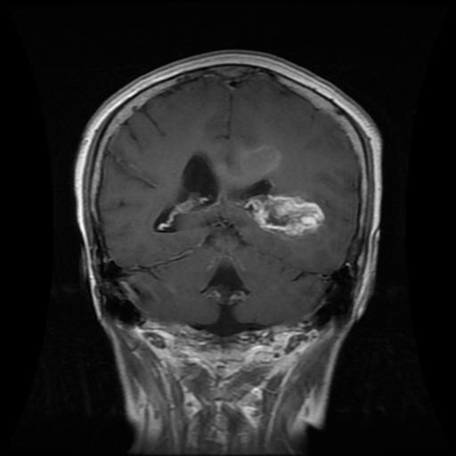 | 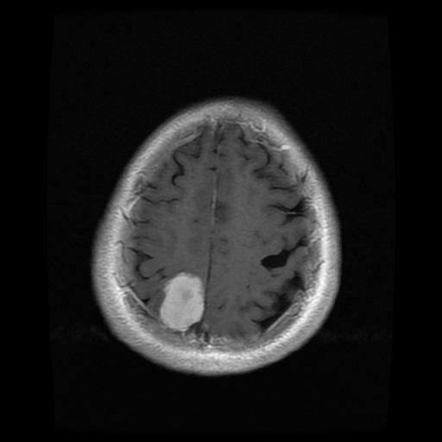
No Tumor | Pitutory
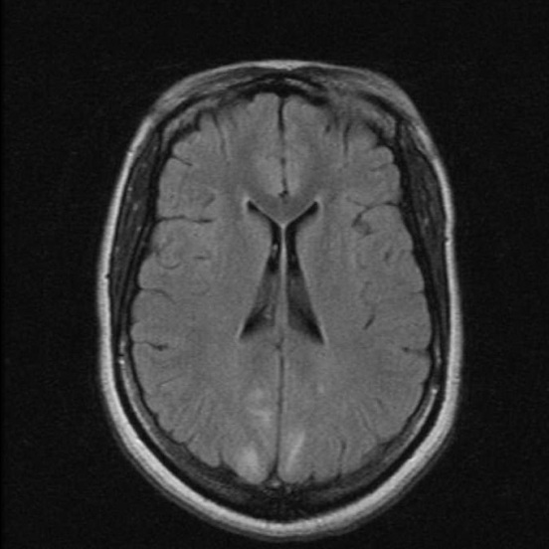 | 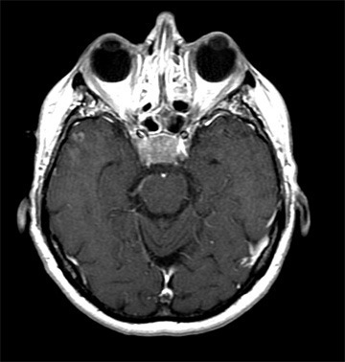

Fig.5.1 Trained Input image of Brain tumor

B.2 Output:
SNO | implementation | Output
1 | ResNet-50 | Epoch 1/25  7/7[===============] – 58s 8s/step - loss: 0.7201 - accuracy: 0.6941 - val loss: 0.6195 – val_accuracy: 0.7083  Epoch 2/25  7/7[===============] – 57s 8s/step - loss: 0.3918 - accuracy: 0.8311 - val loss: 0.2388 – val_accuracy: 0.9173
2 | VGG-16 | Epoch 1/25  -14s – loss: 0.6931 – accuracy: 0.5250 – val_loss:0.6931 – val_accuracy:…  Epoch 25/25  -12s – loss: 0.0953 – accuracy: 0.9700 – val_loss: 0.1034 – val_accuracy:  Test accuracy: 0.95.
3 | Inception v3 | Epoch 1/25  -40s - loss: 0.6931 – accuracy: 0.5250 – val_loss:0.6931 – val_accuracy:…  Epoch 25/25  -38s – loss: 0.0953 – accuracy: 0.9700 – val_loss: 0.1034 – val_accuracy:  Test accuracy: 0.95.

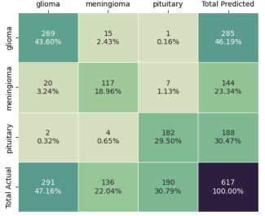
Fig. 5.2 CONFUSION MATRIX FOR VGG-16 ALGORITHM

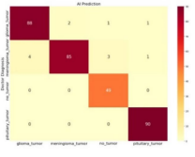
Fig. 5.3 CONFUSION INCEPTION V3 ALGORITHM

REFERENCES

- Sandra Steyaert, Yeping Lina Qiu Yuanning Zhen, Pritam Mukherjee, Hannes Vogel and Olivier Gevaert(2022) --Multimodal data fusion of adult and pediatric brain tumors with deep learning.
- Arshia Rehman, Saeeda Naz, Muhammad Imran Razzak, Faiza Akram, Muhammad Imran(2021) - A Deep Learning-Based Framework for Automatic Brain Tumors Classification Using Transfer Learning
- Neelum Noreen, Sellappan Palaniappan, Abdul Qayyum , Iftikhar Ahmad, Muhammad Imran, And Muhammad Shoaib,(2020) -- A Deep Learning Model Based on Concatenation Approach for the Diagnosis of Brain Tumor.
- Ahmet Çinar, Muhammed Yildirim(2020) -- Detection of tumors on brain MRI images using the hybrid convolutional neural network architecture.
- Soheila Saeedi, Sorayya Rezayi, Hamidreza Keshavarz, and Sharareh R. Niakan Kalhori,(2020) -- MRI-based brain tumor detection using convolutional deep learning methods and chosen machine learning techniques.
- Md Ishtyaq Mahmud, Muntasir Mamun and Ahmed Abdelgawad,(2022)-- A Deep Analysis of Brain Tumor Detection from MR Images Using Deep Learning Networks.
- Sandra Steyaert, Yeping Lina Qiu, Yuanning Zheng, Pritam Mukherjee, Hannes Vogel3 & Olivier Gevaert(2020) -- Multimodal deep learning to predict prognosis in adult and pediatric brain tumors.
- Arshia Rehman, Saeeda Naz, Muhammad Imran Razzak, Faiza Akram, Muhammad Imran,(2023) -- A Deep Learning-Based Framework for Automatic Brain Tumors Classification Using Transfer Learning
- Ayesha Younis, Qiang Li, Zargaam Afzal, Mohammed Jajere Adamu,Halima Bello Kawuwa, Fida Hussain And Hamid Hussain,(2020) Abnormal Brain Tumors Classification Using ResNet50 and Its Comprehensive Evaluation.
- Salman khan, Jabiar Del Ser, Victor Hug,(2021)-Deep Learning For Multi Grade Brain Tumor, Classification In Smart Health Care
- Lihong Zheng,Hamid Ali,Ahmmed Ali,Mingying,(2023)-Image segmentation For MRI Brain Tumor Detection Using Machine Learning
- Sohaid Assasis,Wenhui Yi,Jinhai Si,Tao Ai,(2022)-Improving Effective Different Transfer In Deep learning Detecting Brain Tumor
- Ruqsar Zaitoon,Hussain Syed(2023)-Ru-Net2+:Deep Learning Algorithm for Accurate Brain tumor Segmentation

- Mohammed Shajakhan,Mahbubur Rahman,(2021)-VGG-SENet:A VGG Net-Deep Learning Brain Tumor Detection
- Ahmet Cinar,Mohammed Yildirin,(2020)-Detection Of Brain Tumor Using MRI Images The Hybrid CNN

